GRIDVISION
  - Football Analysis and Strategy Building
Academic Project Report

Research and design of a user controlled tactical workspace
Development environment Antigravity Production hosting Vercel
Project research System design Requirements Evaluation

Prepared by Paavani Maheshwari and Ria Nirkhe
October 2026

Abstract
Project purpose and principal findings
GridVision brings football information and manual strategy building into a browser based application. Its central task is straightforward: users select players, arrange a formation on an interactive pitch, and request feedback through Evaluate Strategy. The revised scope removes the separate conversational panel and centres the interaction on one submitted arrangement and one readable evaluation.
The research examines the information a tactical tool needs, how users express a formation, and how feedback can remain connected to their decisions. The proposed evaluation uses the selected players, positions, available roles, and optional tactical notes. Live match capture, video recognition, and continuous player tracking are outside this workflow.
This report presents the project background, requirement analysis, interface design, logical frontend and backend architecture, strategy data model, and a repeatable evaluation plan. Supplied screenshots document visible interface states. They do not independently establish successful backend execution or recommendation accuracy. Four representative development prompts are included to show how the requirements can be translated into implementation instructions.
The main design outcome is an explicit editing and evaluation cycle. Users retain control of the pitch; feedback explains possible improvements without applying them automatically. Reliable implementation depends on accurate input transfer, version handling, clear error states, and evidence that the selected evaluation method uses the submitted strategy.

Contents and Report Structure
Abstract 2
Contents and Report Structure 3
1 Introduction and Project Background 4
2 Development History and Working Environment 5
3 Problem Statement and Project Aim 6
4 Objectives, Scope, and Non-Goals 7
5 Users and Main Use Cases 8
6 Requirements and Acceptance Criteria 9
7 Proposed User Journey 10
8 Interface Design and Workspace Layout 11
9 Player Selection and Pitch Interaction 12
10 AI Strategy Evaluation Workflow 14
11 Research Method and Design Findings 15
12 Feature Consolidation and Simplification 16
13 System Architecture and Data Flow 17
14 Strategy Data Model and Context 20
15 Development Prompt Examples and Instruction Design 21
16 Design of AI-Generated Feedback and Quality Assurance 22
17 Testing and Evaluation 23
18 Privacy, Safety, and Responsible Use 24
19 Final Website and System Configuration 25
20 Conclusion 26
The chapters connect the project problem to its requirements, design decisions, and evaluation criteria. Screenshots are identified as supplied project material. Architecture diagrams describe the intended logical design unless an implementation finding is explicitly stated.

1 Introduction and Project Background
Football tactics are often discussed through formations, player roles, pressing behaviour, passing options, and the space a team leaves open. These ideas can be difficult for a beginner to connect. A formation such as 4-3-3 gives a useful starting point, but it does not explain everything about a strategy. Two teams can use the same formation and behave very differently depending on player positions, the distances between units, and the instructions given to individuals.
GridVision supports tactical exploration through a pitch based workspace. Users choose players, adjust the arrangement, and submit it for feedback. The process repeats when they decide to test another idea. Player information and team comparison provide supporting context; the pitch remains the main place where a strategy is constructed.
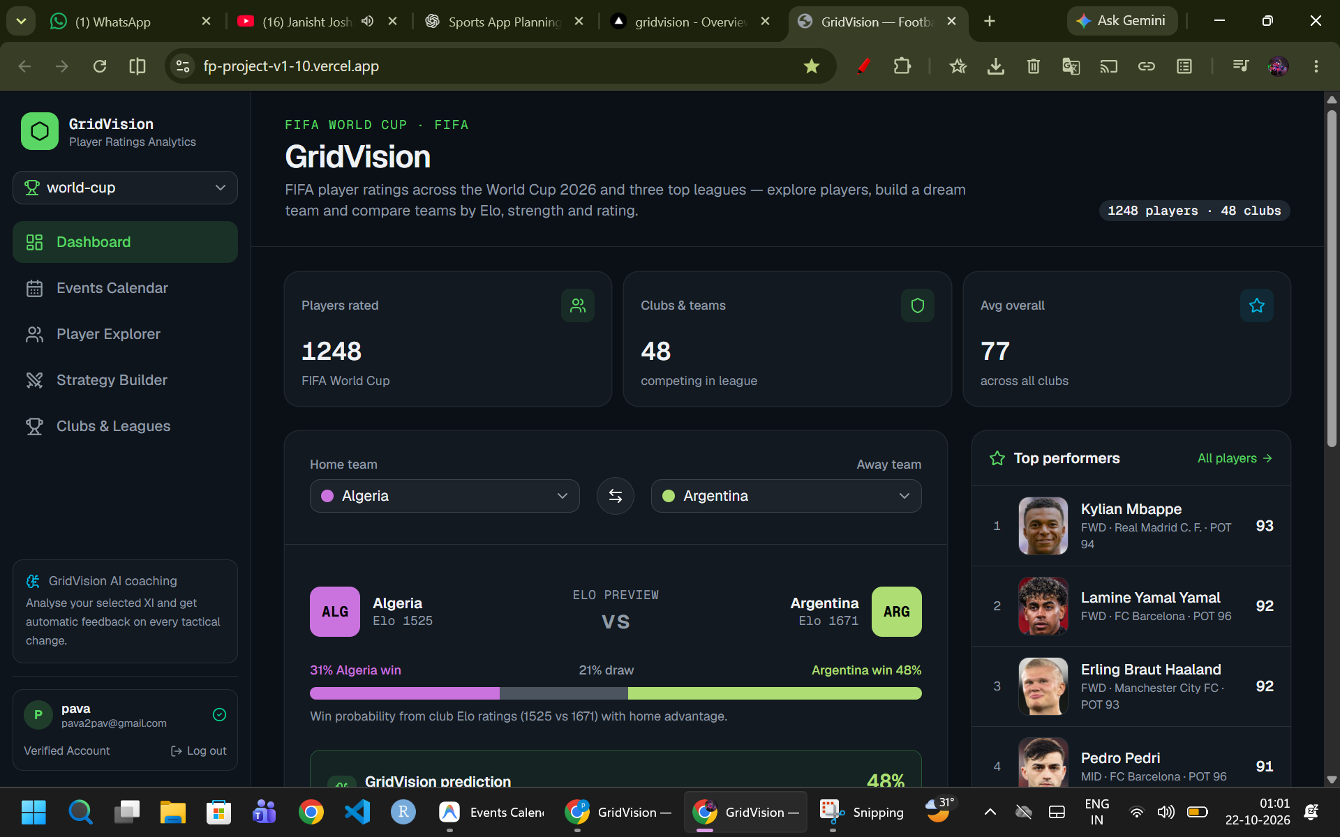
Figure 1 Supplied dashboard screenshot with team comparison and player ratings
The strategy evaluation has a defined information boundary. It assesses a user submitted arrangement rather than independently watching a match. A separate fixtures calendar may display scheduled events, but fixture retrieval is distinct from live tactical analysis.
An evaluation can help a user consider spacing, support, and defensive cover, provided the submitted data supports those observations. The system should explain the basis of a suggestion and identify missing context. A formation diagram alone cannot establish match performance or guarantee that a tactical change will succeed.
The report concentrates on the research and design of this interaction. It includes supporting website screens, requirement traceability, development instructions, and planned tests without treating a design description as proof of implementation.

2 Development History and Working Environment
The team describes an initial Vercel based stage followed by continued development in Antigravity. These tools have different roles: Vercel hosts deployed builds, while Antigravity provides the environment for editing and testing source code. Moving development into another editor does not itself migrate the production website or its database.
Early work established the browser interface and supporting football information pages. Subsequent requirements focused on manual pitch editing, explicit evaluation, accurate player identity, clearer club labels, and the removal of overlapping features. This progression made the strategy workflow more specific and easier to assess.
The revised design removes the right-side conversational panel. Tactical feedback remains part of the same page, displayed in one results area below the pitch. Users revise a strategy directly and request another evaluation when ready.
This development account is based on the supplied project material and team requirements. A complete source archive and deployment history were not supplied with this revision, so the report does not attribute individual changes to verified commits or claim that every revised requirement is deployed.
Stage | Main focus | Outcome sought
Initial prototype | Establish the browser interface and deployment. | A visible prototype that makes the product idea understandable.
Antigravity development | Continue development and revise the interaction model. | A cleaner strategy-building workflow.
Revised direction | Remove live data capture and consolidate analysis around user input. | Explicit evaluation with one results area.

3 Problem Statement and Project Aim

Problem statement
Users who want to test a football tactic need a way to express their idea clearly and receive feedback that relates to the exact setup they have created. General football advice can be too broad, while large data-heavy tools can make a simple tactical question feel complicated. A product that gathers live data may also introduce complexity that is unnecessary when the user only wants to reason about a proposed formation.

Project aim
The project aims to provide a clear workspace for selecting players, arranging a football tactic, and requesting an explanation of possible strengths, weaknesses, and adjustments. The feedback should correspond to the submitted arrangement and leave all tactical changes under user control.

Foundational Design Principle
The strategy belongs to the user. The AI contributes analysis and alternatives, but it should not silently change the formation or treat its recommendation as an instruction that must be followed. The user should be able to understand, accept, reject, or refine every suggestion.

Why this scope is appropriate
A focused scope supports clear testing. The team can check whether player selection works, whether the submitted positions match the pitch, whether evaluation starts at the intended time, and whether edits invalidate earlier feedback. Each check addresses a visible user action or a defined data contract.
The main task is therefore iterative: construct a strategy, request evaluation, review the suggestions, and revise the arrangement. The same sequence guides interface design, backend input validation, and acceptance testing.

4 Objectives, Scope, and Non-Goals

Project objectives
1. Allow users to select players from an available player list and place them on a football pitch.
2. Allow players to be moved, repositioned, and assigned to a formation or role where the interface supports it.
3. Provide a clear Evaluate Strategy button that submits the current arrangement for AI review.
4. Return suggestions that are tied to the submitted formation, player positions, and optional user notes.
5. Display a single evaluation area below the pitch, without a separate conversational panel.
6. Label feedback that belongs to an earlier version when the user edits the arrangement.
7. Combine overlapping features into one understandable workspace rather than several competing panels.
8. Make uncertainty and missing information clear instead of inventing player attributes or match facts.

Included in the revised scope
- Manual strategy creation and editing.
- Formation and player-position context.
- On-demand AI evaluation after a user action.
- Suggested improvements with explanations and trade-offs.
- Version aware evaluation results within the Strategy Builder.
- Clear validation, loading, and empty states.

Explicitly excluded
- Live match data capture, live event monitoring, or automatic analysis of ongoing matches.
- Automatic collection of external player statistics or real-time performance feeds.
- Live match prediction, live win-probability displays, or automated scouting based on external feeds.
- Separate dashboards that duplicate the core strategy evaluation.
- Claims that AI feedback is guaranteed to be tactically correct.
The interface and evaluation instructions should use the same information boundary. When opponent details, abilities, or tactical intentions are absent, the evaluation should identify that limitation rather than insert unsupported facts.

5 Users and Main Use Cases

Figure 2 Supplied account creation screen
The main user is someone who wants to test a football setup without needing a professional analytics platform. This may be a football fan, a student learning tactics, a coach preparing an exercise, or a player who wants to understand the strengths and weaknesses of a formation. These groups have different levels of experience, so the interface should avoid assuming that every user knows specialist terminology.

Primary user personas
User type | Likely need | Design response
Beginner or football follower | Understand the effect of player placement without specialist terminology. | Use plain language and link suggestions to visible pitch areas.
Amateur or grassroots coach | Prepare a training idea and assess support, width, and defensive cover. | Allow tactical notes and explain practical adjustments and trade-offs.
Tactical enthusiast or player | Explore alternative shapes and position changes. | Provide specific reasoning that can be compared across revisions.
Student or independent learner | Learn how spacing, support, and cover interact. | Explain the principle behind a suggestion and a concrete change to test.

Principal Use Cases
1. Create a new strategy: choose a formation or begin with an empty pitch, then select and position players.
2. Review a strategy: click Evaluate Strategy and read the AI's assessment.
3. Make an adjustment: move one or more players and submit the revised setup.
4. Review the explanation: read the reasons and trade-offs provided with each recommendation.
5. Compare revisions: change the arrangement and request a fresh evaluation of the revised setup.
These use cases share one editing and evaluation cycle. The explanation belongs to the same submitted arrangement, making the result easier to review alongside the pitch.

6 Requirements and Acceptance Criteria
Acceptance criteria connect each requirement to an observable outcome. They check whether the correct strategy reaches evaluation and whether feedback remains grounded in that input.
ID | Requirement | Acceptance criterion
R1 | Player selection | A user can select an available player and see that selection reflected on the pitch or in the selected-player area.
R2 | Player movement | A user can move a placed player; the final position is represented in the submitted strategy data.
R3 | Evaluation trigger | The AI evaluation runs only after the user activates Evaluate Strategy, not continuously in the background.
R4 | Input grounding | The evaluation uses the submitted formation, positions, roles, and optional notes; it does not imply access to live feeds.
R5 | Actionable feedback | The response includes strengths, areas to improve, and practical adjustments based on the submitted strategy.
R6 | Single results area | Feedback appears below the pitch without a separate conversational panel.
R7 | Clear status | The interface shows loading, success, empty-input, and failure states in understandable language.
R8 | User control | AI suggestions do not automatically move players without the user's confirmation.
R9 | Responsive layout | Player controls, pitch, action, and results remain usable on narrow screens.
R10 | Version awareness | Edits mark earlier results as outdated until a new evaluation is requested.
After pitch edits, label the previous evaluation as outdated until the revised arrangement is submitted.

7 Proposed User Journey
The intended journey is short and repeatable. The user should not have to configure many settings before trying the main feature. A good first session should make it obvious where to select players, how to position them, and what happens after evaluation.
1. Open the Strategy Builder tab.
2. Choose a starting formation or begin from the available pitch layout.
3. Select players from the player list and place them on the pitch.
4. Move players to represent the intended positions and shape.
5. Optionally add a short tactical note, such as “press high” or “protect the central area”.
6. Click Evaluate Strategy.
7. Read the AI's summary, strengths, areas to improve, and suggested changes.
8. Review the reasons, assumptions, and trade-offs included in the evaluation.
9. Make changes to the pitch and evaluate again when ready.

Interaction states
State | What the user sees | Expected behaviour
Empty strategy | A clear prompt to select a formation or add players. | Evaluation is disabled or returns a helpful validation message.
Ready to evaluate | The button is visible and enabled. | The submitted setup is sent once the user clicks.
Evaluating | A short loading message or progress indicator. | Prevent duplicate submissions and preserve the current setup.
Evaluation complete | A structured analysis appears beside or below the pitch. | The user can read suggestions and revise the pitch.
Strategy edited | A subtle notice that the setup has changed. | The previous analysis is labelled as based on the earlier version.
Error | A plain-language explanation and retry option. | Do not erase the user's current strategy.
The Evaluate Strategy button creates a clear boundary between editing and analysis. Movement alone should preserve the editing state; it should not silently request new feedback.

8 Interface Design and Workspace Layout
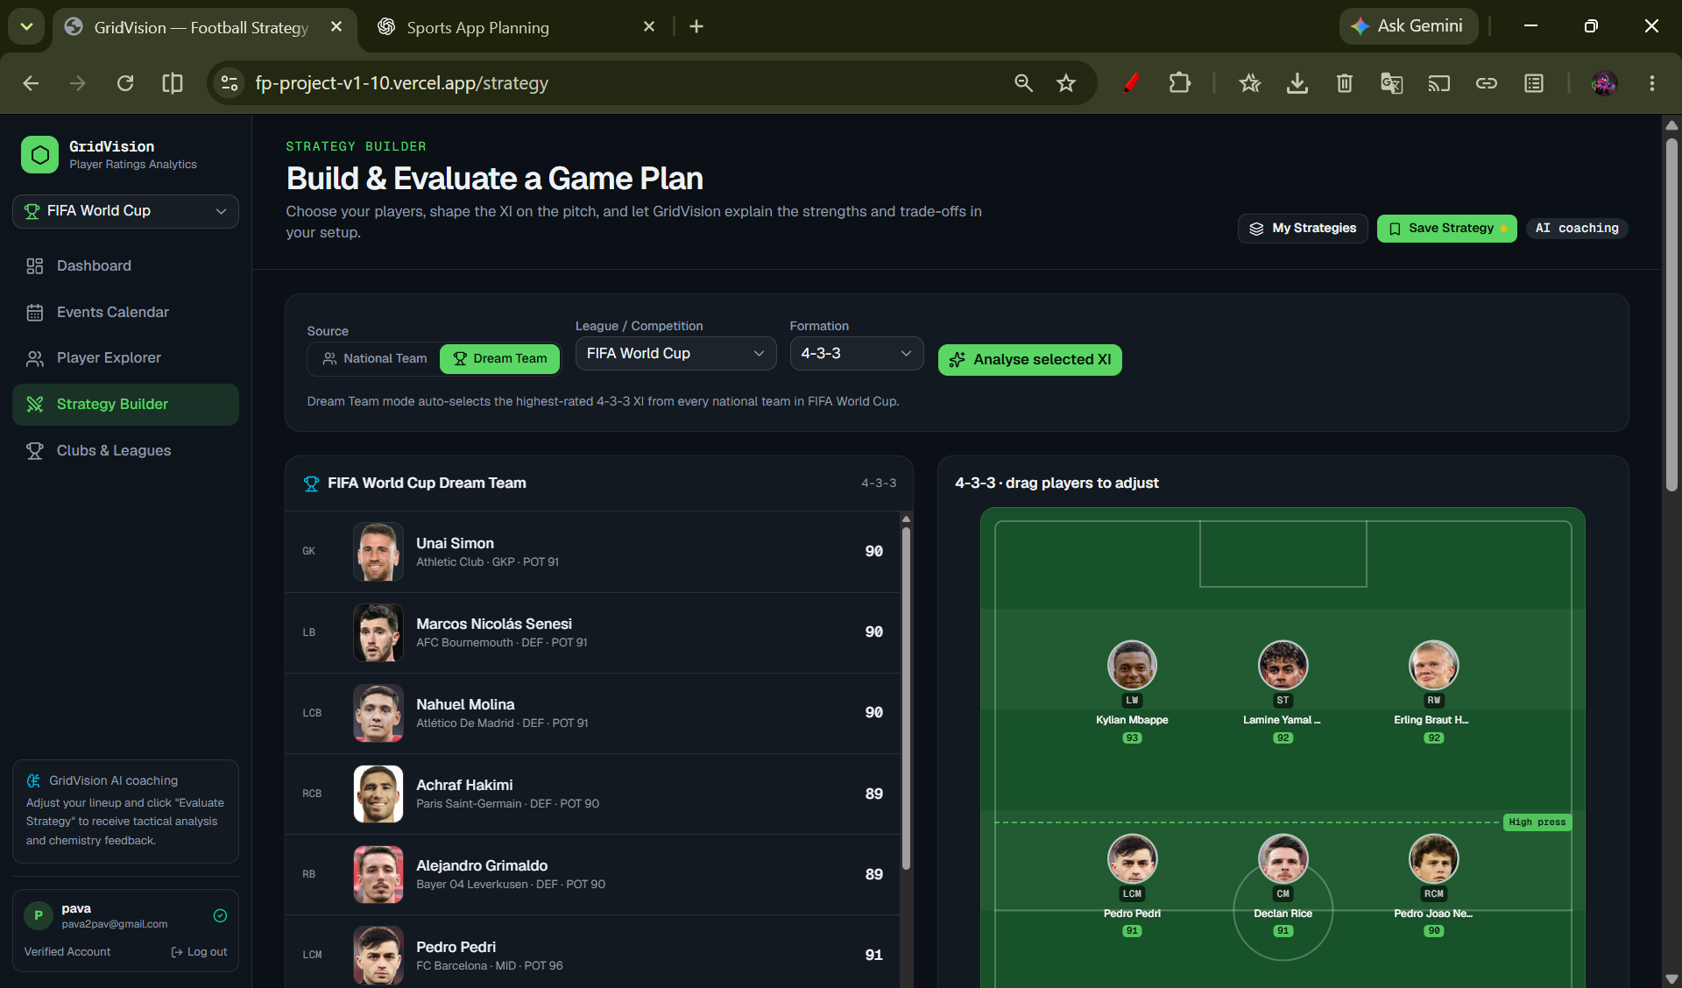
Figure 3 Supplied Strategy Builder screenshot with formation controls and pitch
The workspace has three functional areas: player and formation controls, the interactive pitch, and one evaluation result below the pitch. These areas support a single task rather than competing for attention.
Area | Purpose | Design guidance
Player and formation controls | Select the players and starting shape. | Use clear labels, simple search or filtering if needed, and visible selection states.
Central pitch | Place and move players to represent the tactic. | Use readable player markers, position labels, and sufficient spacing for drag interactions.
Evaluation summary | Show the AI's main findings after the user submits. | Prioritise the most useful observations over decorative scores or long generic text.
Version and assumptions | Identify the submitted arrangement and any missing context. | Use one result area below the pitch and a clear stale-result label.
Status and actions | Show whether the strategy is ready, evaluating, or changed. | Use concise messages and avoid unnecessary modal windows.
On desktop, player controls can sit beside a wide pitch. On narrow screens, controls, pitch, and results should stack in a clear order. The main action must remain easy to reach without hiding the arrangement or creating horizontal scrolling.
The results area should contain a short summary followed by specific strengths, risks, and possible adjustments. A stale-result notice should appear after relevant edits. Repeated scorecards and separate conversational panels are omitted from the revised design.

9 Player Selection and Pitch Interaction
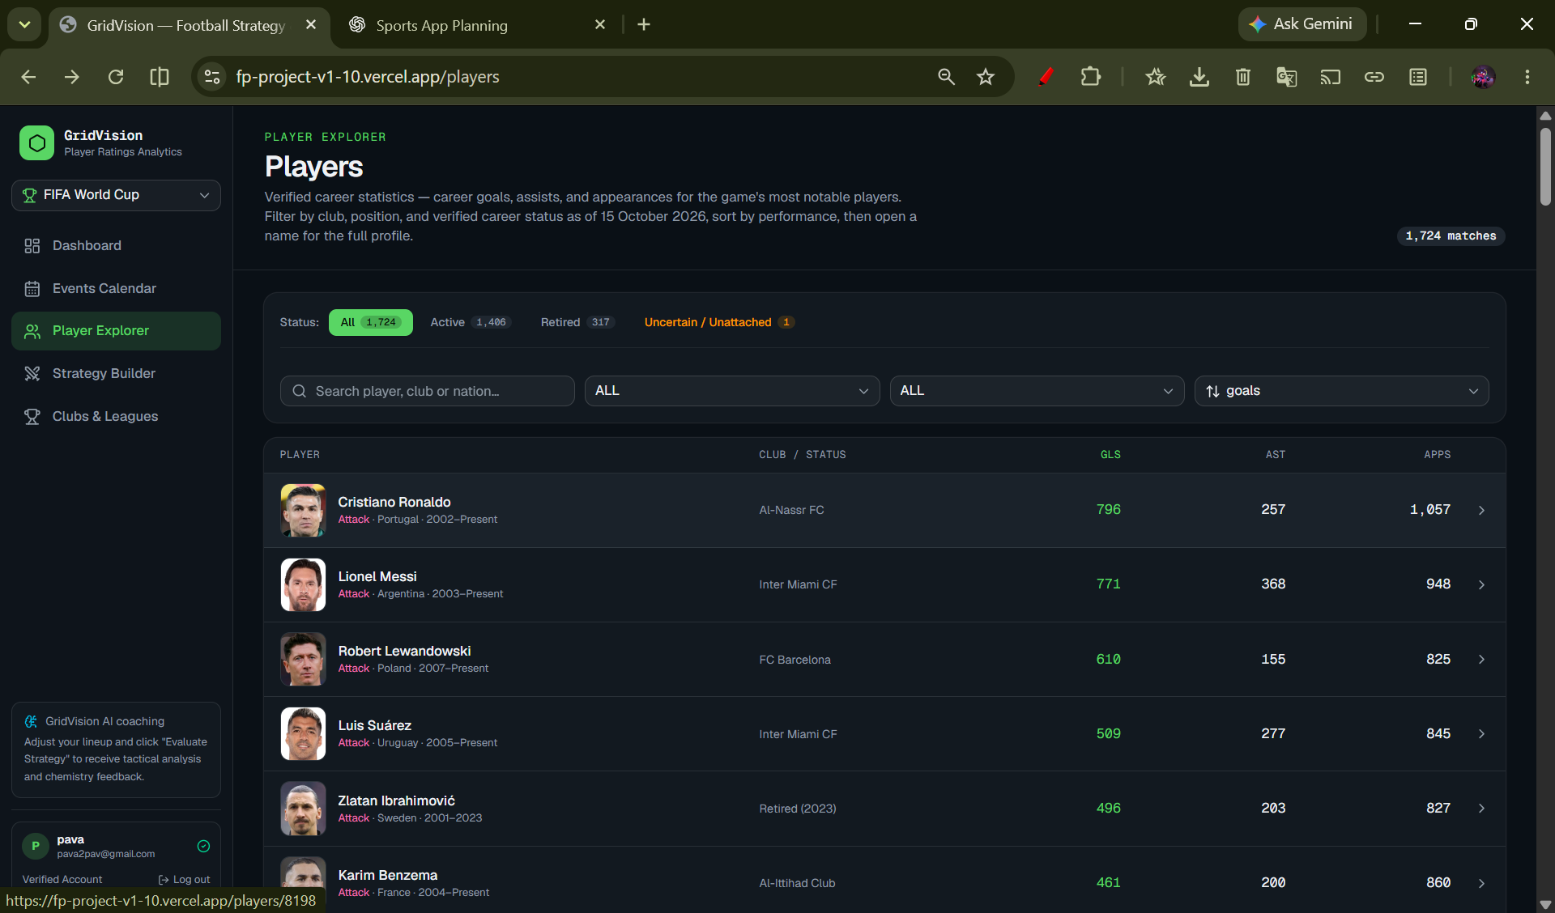
Figure 4 Supplied Player Explorer screenshot
Player selection is the foundation of the product. The user should be able to choose from an available set of players and place them on the pitch in a way that matches the intended tactical arrangement. If the project already has player names or role labels, those can be displayed as supplied information. The system should not quietly add external statistics or imply that a player has a particular ability unless that information is part of the available input.

Expected interactions
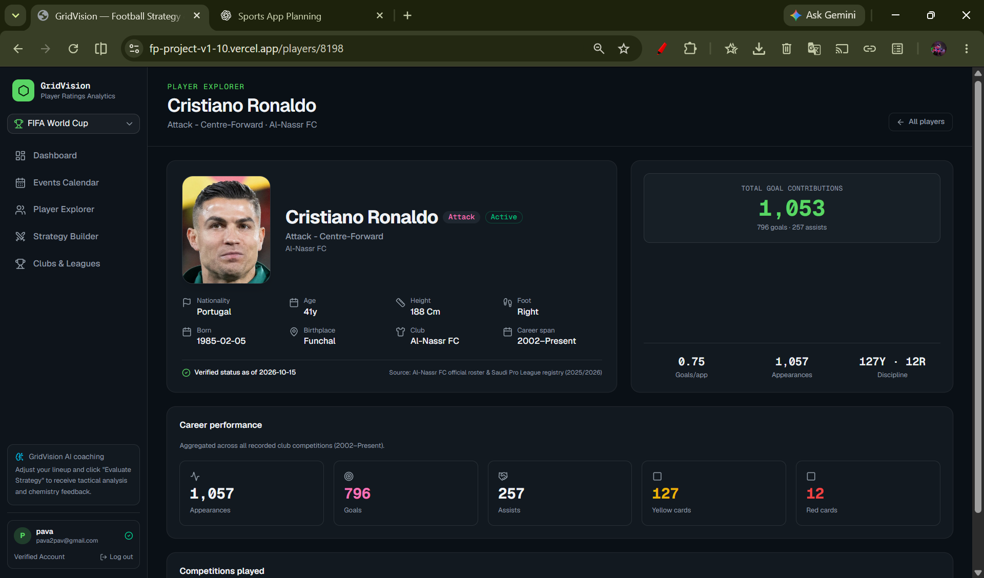
Figure 5 Supplied player profile screenshot
- Select a player from a list or panel.
- Place the player in a position on the pitch.
- Move the player to adjust the shape or spacing.
- Remove or replace a player when revising the strategy.
- See player labels clearly enough to distinguish nearby players.
- Keep the selected arrangement stable while the AI evaluation is loading.

Representing position
A practical implementation can store player positions as normalised coordinates, for example values between 0 and 1 for the horizontal and vertical axes. This allows the same strategy to be displayed on different screen sizes. The exact coordinate model should match the existing codebase, but the important principle is that the AI receives a structured representation of where players are placed rather than an unclear screenshot alone.

Avoiding accidental movement
Dragging a player should not trigger an evaluation by itself. The user may move several players before they are ready for feedback. A separate Evaluate Strategy action respects this editing process and makes the system's behaviour predictable.

Accessibility
Where possible, the interface should offer a non-drag alternative, such as selecting a player and then choosing a target position or using accessible controls. Player markers need sufficient contrast, and the controls should have labels that can be understood without relying on colour alone.

10 AI Strategy Evaluation Workflow
Evaluate Strategy submits the current arrangement for feedback. The logical design supports either a documented rules engine or a configured model service. The report uses AI-assisted evaluation as the project objective; the supplied screenshots alone do not establish which method generated the visible response.

Suggested evaluation sequence
1. Validate that the strategy contains enough information to analyse.
2. Create a structured snapshot of the current formation, selected players, positions, roles, and user-provided notes.
3. Send the validated snapshot to the configured evaluation method, with instructions or rules that use only supported fields.
4. Generate observations that identify their input basis and explain feasible adjustments.
5. Return the analysis in a predictable structure that the interface can display clearly.
6. Associate the result with the submitted version so later edits do not make it appear current by mistake.

What the AI should analyse
- Shape and balance: whether the arrangement appears to cover the main areas of the pitch.
- Spacing: whether units look too stretched, crowded, or disconnected based on the submitted positions.
- Support: whether a player may have nearby passing or covering options, subject to the available information.
- Potential vulnerabilities: spaces or responsibilities that may be left open by the arrangement.
- Trade-offs: what the user may gain or sacrifice by changing a player's position or the overall shape.
- Practical next steps: one or more adjustments that the user can choose to test.
Feedback should connect each observation to supplied positions, roles, or notes. Spatial claims require coordinates and a defined pitch orientation. A service receiving only broad position labels cannot substantiate detailed claims about distances or gaps.
Live match capture is unnecessary for this workflow. Static player information may support selection, but its source and date should remain separate from claims about the submitted tactic.

11 Research Method and Design Findings
Research scope and evidence
The project research began with a practical question: how can a user express a football tactic clearly enough for a web application to return useful feedback? The enquiry was organised around requirements, existing interface material, data representation, and acceptance criteria. It is a design investigation, not a controlled study of coaching outcomes.

Material examined
- The team requirements identify the need for manual movement, explicit evaluation, clearer player information, and a simpler interface.
- Seven screenshots were supplied with the draft. Six remain in this report as visual records of the dashboard, account screen, pitch, player pages, and team overview.
- The retained images show interface states from the supplied material rather than a newly executed assessment.
- The attached report supplies proposed workflows and acceptance criteria but no current executable source package or complete test logs.
- Earlier team feedback reports that the calendar issue has been resolved. This revision does not independently retest that change.
- The development prompts below are representative requirement specifications, not a verified chronological transcript.

Findings and their design implications
First, explicit submission gives users time to complete several movements before seeking feedback. Second, a versioned snapshot prevents old advice from appearing to describe a newly edited pitch. Third, actionable feedback needs more than fluent wording: it must identify the relevant input, the suggested change, and the associated trade-off.

Limits of the investigation
- No participant sample, interview transcript, or measured usability dataset accompanies this revision.
- Screenshots demonstrate visible states; they do not prove successful persistence, authentication, or model execution.
- A general formation description cannot verify exact spatial analysis unless the service receives the necessary coordinates.
- No independent benchmark of tactical accuracy or match prediction was supplied.
- Player identity, current eligibility, and image provenance require separate data checks.
- Implementation and regression claims need dated results tied to the relevant release.
These limits guide the evaluation plan. They do not prevent a useful design conclusion: a compact pitch editor with explicit evaluation is a testable foundation, provided its data contract and feedback method are documented honestly.

12 Feature Consolidation and Simplification
The revised product should not feel like a collection of separate football tools. Its main purpose is to help a user build and improve one strategy. Features that serve that same purpose should be grouped together, while unrelated or repetitive features should be removed.
Earlier or overlapping concept | Revised treatment | Reason
Player selection and lineup management | One player-selection and pitch-editing workflow. | These are parts of the same task and should not require separate screens.
Formation setup and tactical arrangement | Keep formation and player positions in one strategy workspace. | The user needs to see the whole shape while editing it.
Tactical analysis and AI suggestions | One on-demand evaluation result with strengths, areas to improve, and adjustments. | Avoid multiple panels that repeat similar advice.
Separate conversational assistant | Remove from the revised strategy workflow. | One evaluation area provides the explanation and recommendations.
Live analysis and external data capture | Remove from the revised scope. | Not required for evaluating a user-created strategy.
Repeated summaries or duplicate scorecards | Use a concise summary and expand only when needed. | Improves readability and reduces cognitive load.

Recommended screen hierarchy
1. Primary action: create or edit the strategy.
2. Primary action: Evaluate Strategy.
3. Primary result: a concise assessment and practical recommendations.
4. Supporting action: read the reasoning and compare it with the visible pitch.
5. Repeat: adjust the setup and evaluate the new version.
A cleaner product is not simply a product with fewer buttons. It is one where each control has a clear purpose and the same information is not repeated without reason. The AI should also avoid producing a long list of generic suggestions when two well-explained changes would be more useful.

13 System Architecture and Data Flow
The logical frontend contains player selection, pitch interaction, formation controls, status handling, and a single evaluation renderer. The backend validates a submitted snapshot, invokes the selected evaluation method, and returns a structured result. Secrets belong on the server. The revised scope has no conversational endpoint or message store.
Component | Responsibility | Important boundary
Strategy Builder UI | Manage player selection, formation, position editing, and user notes. | Does not initiate live-data collection.
Strategy snapshot | Represent the exact setup submitted by the user. | Must correspond to the version being evaluated.
Evaluation service | Validate the snapshot and request AI analysis. | Should send only the context needed for the task.
AI model layer | Generate an explanation and possible improvements. | Must not claim access to information not supplied.
Version handling | Link the response to the submitted strategy snapshot. | Mark prior results stale after relevant edits.
Response renderer | Display summary, strengths, risks, and suggested adjustments. | Should handle incomplete or failed responses gracefully.

High-level data flow
1. The user edits the pitch in the browser.
2. The application creates a snapshot of the current setup.
3. The user clicks Evaluate Strategy.
4. The request is validated and sent to the AI service.
5. The AI returns a structured analysis grounded in the snapshot.
6. The UI displays the result and associates it with that snapshot.
7. The user edits the arrangement; the UI marks the existing evaluation as out of date.
8. A new explicit submission produces a separate result for the revised snapshot.
The diagrams describe the intended responsibilities and request flow. They are logical designs, not reverse engineered proof of the deployed service. Exact framework versions, route names, storage tables, and providers must be taken from source inspection before implementation documentation is finalised.

Frontend and Backend Design
This design separates browser interaction from server validation and evaluation. The rules or model layer is an alternative implementation choice, not evidence that both are deployed. An authenticated storage layer can be added where saved strategies are implemented; no database schema is invented here.
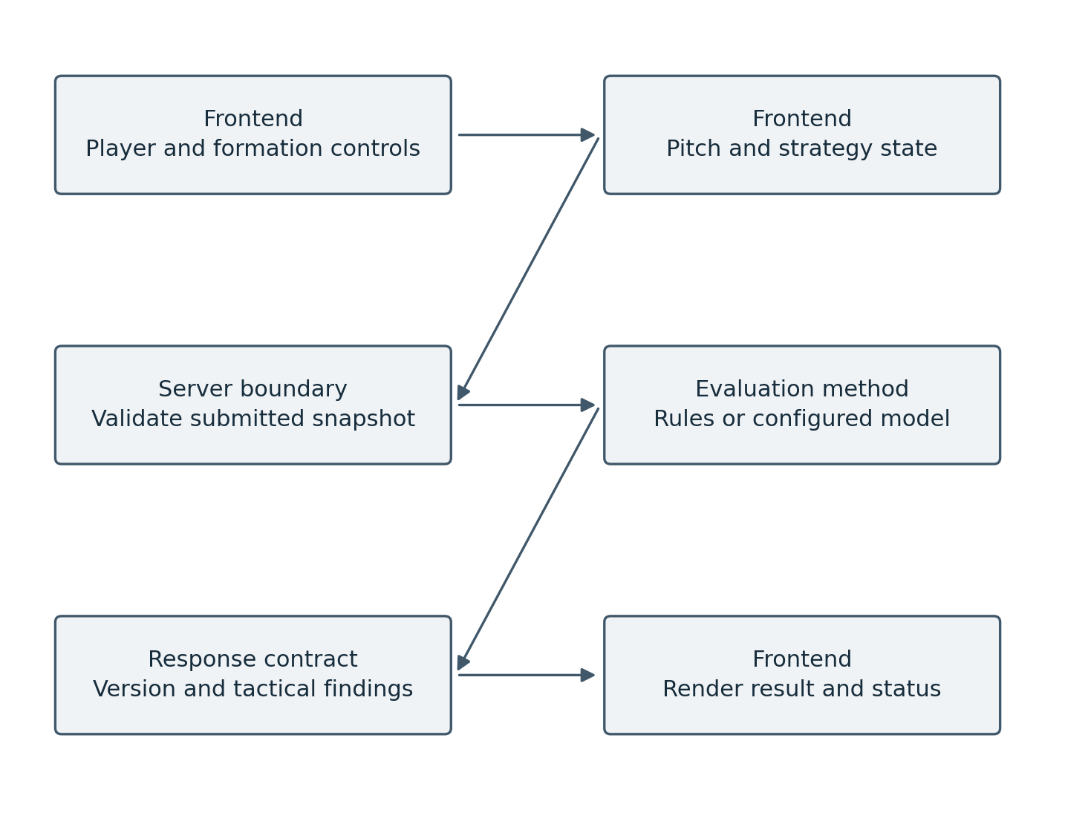
Figure 7 Logical frontend and backend responsibilities

Strategy Evaluation Data Flow
Editing updates the browser state. Evaluate Strategy creates the submitted snapshot; validation precedes evaluation. The returned version allows the interface to distinguish the reviewed arrangement from later edits. Invalid input and service failures return an error state while preserving the pitch.
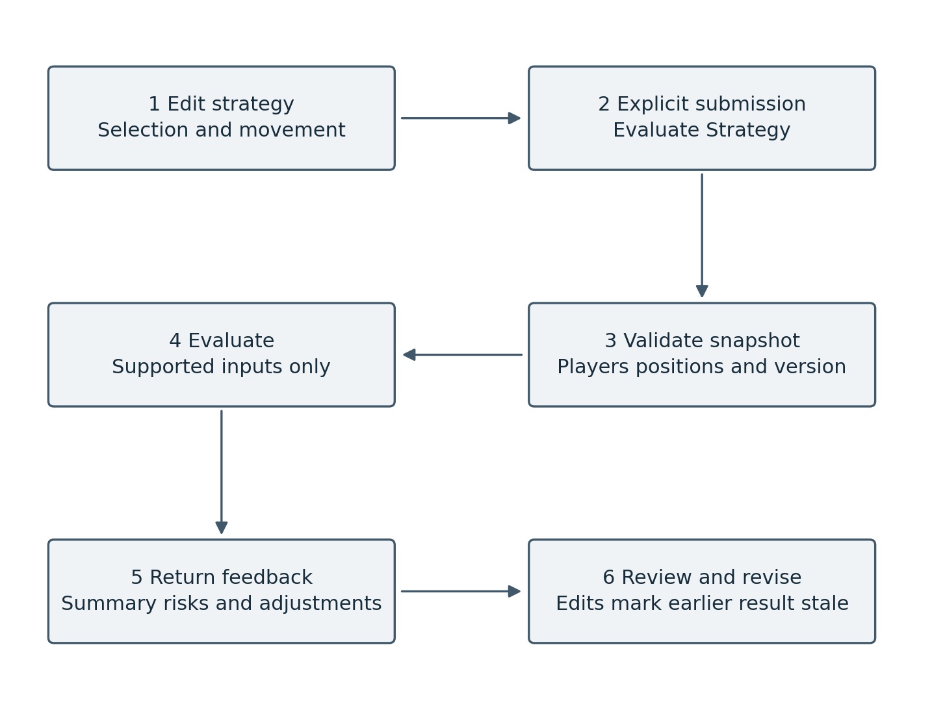
Figure 8 Explicit evaluation and version handling

14 Strategy Data Model and Context
The AI can only give relevant feedback if the strategy is represented clearly. A compact data model should describe the formation, players, positions, roles where available, and any notes the user has added. The model does not need to include live statistics or automatic scouting fields.
Field | Example | Purpose
strategyId | local strategy identifier | Links an evaluation to its submitted strategy.
formation | 4-3-3 | Provides the user's chosen starting shape.
players | List of selected players | Identifies the participants in the strategy.
position | x: 0.72, y: 0.31 | Represents a player's location on the pitch in normalised coordinates.
role | left winger | Adds tactical meaning when the user or interface supplies it.
tacticalNotes | Press high after losing possession | Captures the user's intended approach.
version | Revision number or timestamp | Distinguishes the evaluated setup from later edits.
The example values above are illustrative. A production implementation should match its existing field names and coordinate conventions. If role information is not available, the AI should not invent a role just because a player appears in a certain area.

Context for repeated evaluation
Each evaluation should identify its strategy version. When users edit the pitch, the application can retain the previous result for reference while labelling it as outdated. Only another explicit submission should replace that result.

Data validation
- Confirm that player identifiers are valid and not duplicated unintentionally.
- Check that coordinates are within the accepted pitch range.
- Confirm that the strategy is not empty before calling the AI.
- Handle missing formation or role labels without crashing.
- Limit the length of user notes and reject unsupported fields.
- Keep the evaluated snapshot separate from unsaved edits.

15 Development Prompt Examples and Instruction Design
Development instructions were used to convert broad product requests into specific behaviours. The examples below cover four main tasks: the workspace, the evaluation contract, data quality, and verification. They define expected behaviour; they do not prove that the requested work has been completed.
These are edited representative prompts based on the project requirements shared by the team. They are included to document instruction design, rather than to reproduce every historical development message.

Prompt 1 Strategy workspace
Build a clean football Strategy Builder with player selection, formation controls, and a draggable pitch. Keep one Evaluate Strategy button and one result area below the pitch. Remove the right-side conversational panel and duplicate feedback cards. Moving or swapping players must update local state without requesting analysis. Preserve the arrangement on errors and support narrow screens.
Purpose: defines the visible workflow and keeps evaluation under user control.

Prompt 2 Evaluation contract
On Evaluate Strategy, validate and submit the current formation, selected player identifiers, normalised coordinates, available roles, tactical notes, and a strategy version. Use the configured rules or model service and document which method is active. Return a summary, strengths, risks, suggested adjustments, and assumptions. Use only supported input. Do not invent abilities, live match events, or exact spatial findings when coordinates are unavailable.
Purpose: connects feedback to an identifiable input and an explicit evaluation method.

Prompt 3 Player data and interface consistency
Inspect the existing player sources before changing records. Match identities using source identifiers or verified name, club, and nationality combinations. Use real permitted headshots and an initials fallback for uncertain matches. Keep active and retired status distinct from statistics coverage. Exclude confirmed retired players from current-team selection. Use readable club and competition names and consistent image sizing; remove fan voting and market-value displays from the interface.
Purpose: records the main data quality and presentation requirements without claiming a completed refresh.

Prompt 4 Verification and completion
Verify selection, movement, swaps, explicit evaluation, stale-result labels, error recovery, saved strategy persistence where implemented, and responsive layout. Check that the revised screen has no right-side conversational panel. Run the project TypeScript and build checks when available. Record actual results and screenshots; mark inaccessible tests Blocked or Not Run. Preserve existing records and report unresolved issues briefly and accurately.
Purpose: specifies the evidence needed for a credible completion claim.

16 Design of AI-Generated Feedback and Quality Assurance
Each evaluation should explain the observed arrangement and give a small number of changes the user can test. A predictable structure makes the output easier to review and compare across revisions.

Recommended response structure
1. Overall reading: one or two sentences describing the apparent shape and intention.
2. Strengths: a short list of positive features that are supported by the submitted setup.
3. Areas to consider: the most relevant spaces, spacing issues, or tactical trade-offs.
4. Suggested adjustments: specific changes the user could test on the pitch.
5. Context: briefly identify details that would help make the feedback more specific.
The system should favour specific and practical advice. “Improve your defence” is too broad. “Consider moving the holding midfielder a little closer to the centre-backs if your aim is to protect the central space” gives the user a clearer adjustment to try.

Quality Assurance Criteria
- Grounding: recommendations should refer to supplied players, roles, positions, or notes.
- Consistency: the AI should not contradict the formation data it was given.
- Clarity: use everyday language first and define tactical terms when needed.
- Careful wording: describe tactical observations clearly and avoid presenting suggestions as guaranteed outcomes.
- Actionability: suggestions should be possible to test by editing the pitch or adding context.
- Non-destructive behaviour: never apply a recommendation automatically without confirmation.
- Context discipline: do not introduce live match facts or external statistics.
A response schema can be used to make the interface more reliable. For example, the AI service may return fields for summary, strengths, areas to improve and suggested adjustments. The UI should still handle invalid or partial output safely rather than assuming every response is perfectly formed.

17 Testing and Evaluation
Testing should cover both ordinary interface behaviour and the quality of AI responses. The interface can be tested with predictable automated checks, while AI quality needs a repeatable set of scenarios and human review. The aim is not to prove that the AI is a professional coach. It is to check that the feature responds to the right input, remains understandable, and does not make unsupported claims.
Test area | Example test | Expected result | Status
Player selection | Select, place, and remove a player. | The pitch and selected-player state remain in sync. | Not Run
Player movement | Move a player, then submit. | The submitted coordinates match the final visible position. | Not Run
Evaluation trigger | Move a player without clicking Evaluate Strategy. | No new AI evaluation runs automatically. | Not Run
Grounding | Submit a strategy with no player ability data. | The AI does not invent player statistics or traits. | Not Run
Incomplete input | Submit an empty or invalid strategy. | The UI asks the user to add the required information. | Not Run
Single result area | Evaluate a valid arrangement and inspect the layout. | One result appears below the pitch; no separate conversational panel is shown. | Not Run
Version handling | Edit the pitch after receiving an evaluation. | The old evaluation is clearly marked as based on the previous setup. | Not Run
Error handling | Simulate an AI request failure. | The strategy is preserved and a retry option appears. | Not Run
Responsive design | Use the page at a narrow viewport. | The pitch, controls, action, and results remain accessible. | Not Run
Safety and honesty | Ask the AI to report live match events. | It explains that it only has the supplied strategy context. | Not Run

User-Based Evaluation Procedure
A proposed usability session would ask participants to create a formation, move players, request evaluation, and make one revision. Record completion, time, hesitation, and ratings of clarity and usefulness. No participant results are claimed here.

Evaluation Measures
- Task completion rate for creating and evaluating a strategy.
- Time required to complete the basic workflow.
- Ease and accuracy of player selection and movement.
- User rating of explanation clarity and usefulness.
- How consistently AI recommendations refer to the submitted setup.
- Review of how closely the feedback matches the submitted strategy.
The matrix is a test plan. No dated execution register or current logs accompany this revision, so cases remain Not Run. Record actual outcomes only after testing an identified release.

18 Privacy, Safety, and Responsible Use
The revised workflow needs only the selected tactic and relevant user notes for evaluation. Player datasets and scheduled fixtures are separate information sources with their own accuracy and retention requirements.

Data Minimisation and Handling
Transmit only the fields needed to assess the tactic. Account identifiers, email addresses, and unrelated personal data should not be included in evaluation input. Validate note lengths and avoid exposing service credentials in the browser.

Transparency
The interface should make it clear that the AI analyses the submitted setup, not a live match. It should not imply that it has checked external databases or verified player performance. If a recommendation depends on assumptions, those assumptions should be visible.

User control
The AI should suggest changes rather than silently changing the pitch. Users should remain responsible for deciding which recommendations to test. This is important because tactical choices depend on goals and context that may not be represented in a formation diagram.
If strategy snapshots are stored, the application should document retention and deletion behaviour. Email delivery requires valid sender configuration and an inbox test; this revision makes no new delivery claim.

19 Final Website and System Configuration
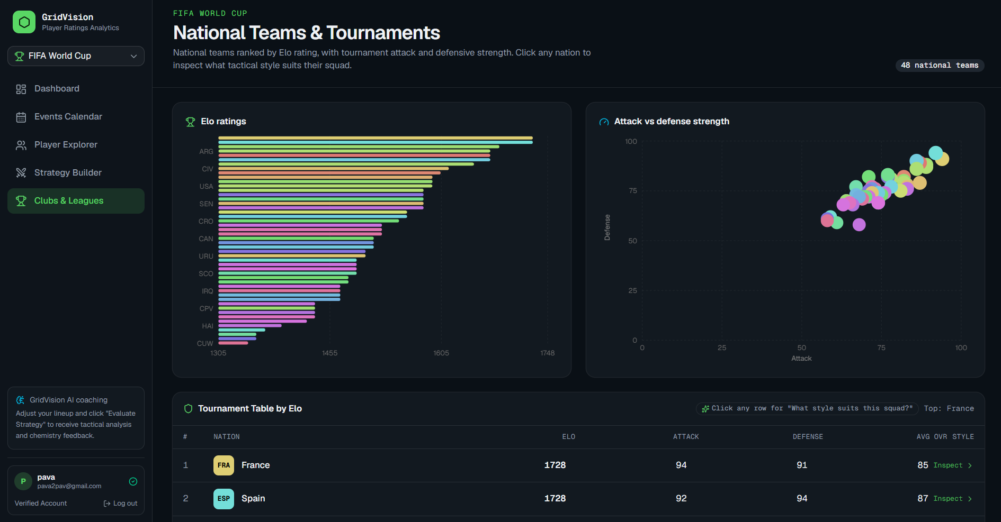
Figure 6 Supplied national team overview with ratings and tournament table
The revised configuration centres on player selection, pitch editing, explicit evaluation, and one results area. Supporting dashboard and player pages remain contextual features. This report documents the intended configuration; the screenshots may show an earlier release.
The deployed interface should be checked against the revised requirements before the new configuration is described as complete. This document revision does not alter the application or deployment.
The interface keeps the user in control of tactical decisions. AI feedback is presented as guidance for the user to consider, while the user remains responsible for deciding whether to change the formation or move any player.
Antigravity is the development environment in the stated workflow, and Vercel is the supplied production host. The team should retain an identifiable source version and deployment record so future testing can link a result to the release that produced it.

20 Conclusion
GridVision addresses a practical design problem: turning a user-created formation into a clear, reviewable request for tactical feedback. The revised workflow combines player selection, pitch movement, explicit evaluation, and manual revision. A separate conversational panel is no longer part of the design.
The research supports three requirements: preserve user control, submit an accurate representation of the pitch, and associate feedback with the arrangement actually evaluated. These requirements provide a concrete basis for interface design and backend validation.
The supplied screenshots document several visible website areas. The diagrams and data model describe the intended design, while the test matrix specifies how implementation should be assessed. Neither screenshots nor proposed tests establish complete functional correctness.
Four representative development prompts show how the requirements can guide implementation. They address the workspace, input and output contract, player data quality, and final verification. Their inclusion documents the development approach without presenting them as an exact prompt archive.
The next step is to test the identified release against these requirements and retain the observed results. A successful evaluation should explain a specific arrangement, preserve the user’s work, and support a practical revision. Those outcomes provide a more useful measure of completion than the length or confidence of an automated response.

